Analysis of Final Project

1. What is the correlation (R2 value) between sales and income?

The correlation R2 Value is **0.88.** This means there is a strong correlation between sales and income as shown in the image below.

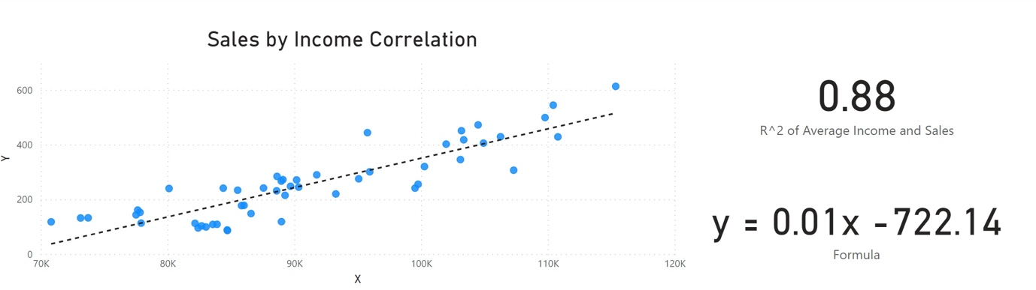

Figure : Linear correlation between sales and income with R^2 and Regression Formula

1. What is the correlation (R2 value) between customer ratings and product return rate?

The R2 correlation value of customer ratings and product return rate is

(**-0.83)** and the trend line is negatively sloped.

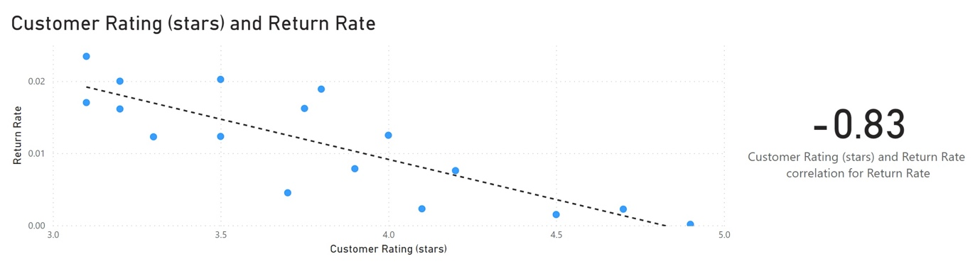

Figure : Customer rating and Return Rate

1. What are the linear regression formulas to predict customer income from customer sales?

**Y = 0.01x – 722.14**

*as indicated in Figure 1*

1. Which customer do you predict has the highest income?

**Jon Little** from Illinois is predicted to have the highest income of about

**$ 476,550.**

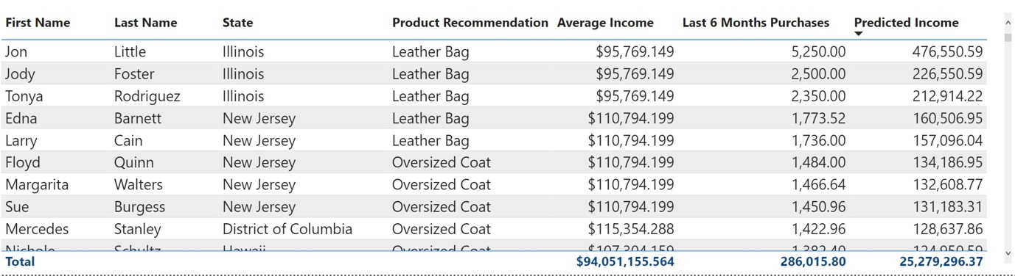

1. Which product will be advertised the most?

Based on the product recommendation approach chosen in this project, **Polo Shirt** will be advertised the most.

